Requirements for Exam Seating

- Generate seating arrangements for exams.
- Choose the corresponding classes to be seated
- Prevent students with the same subject from sitting close to each other.
- Choose the particular year or branch. Upload timetable, student details
- Reset data, including student information and seating arrangements.
- Add, subject, Class, Exam, Hall (Room), bulk student export using excel or csv.
- Add faculty option (class invigilator during exam one or more than one, max three.)
- Seating arrangement chart.
- Seating arrangement chart excel or pdf
- User login (admin or teachers only)
- Generate hall ticket using student data like. Name, class, room no, Roll no.
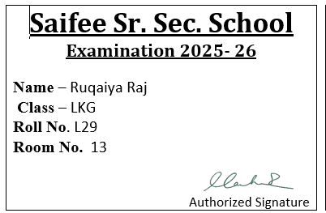
Hall ticket sample
Report sample
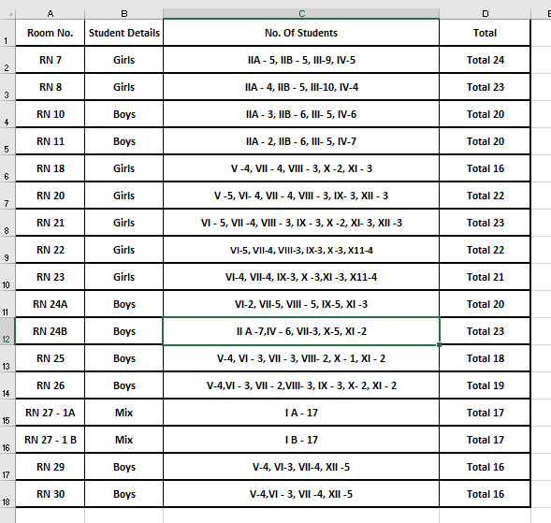
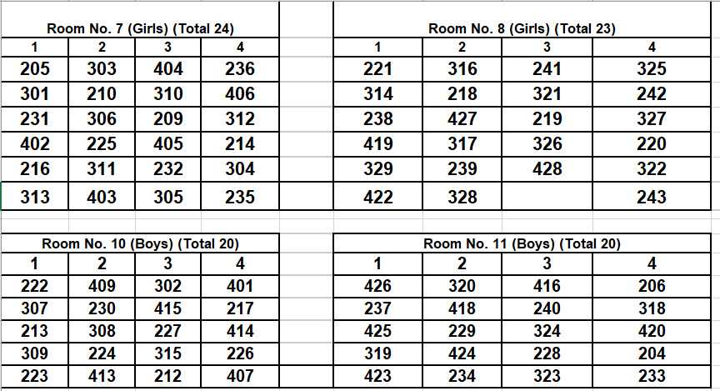
Room seating arrangements
Note: seating arrangement gender wise and mix both should be there, because in big class like 8th to 12th girls and room is different and in small class like 1 to 6 they can sit both in exam room.

